How To Use Github in Cyber Security Task

By

Solanke abayomi s.

fe/24/6766294920

to

tedprime (Alc)

abeokuta

ogun state

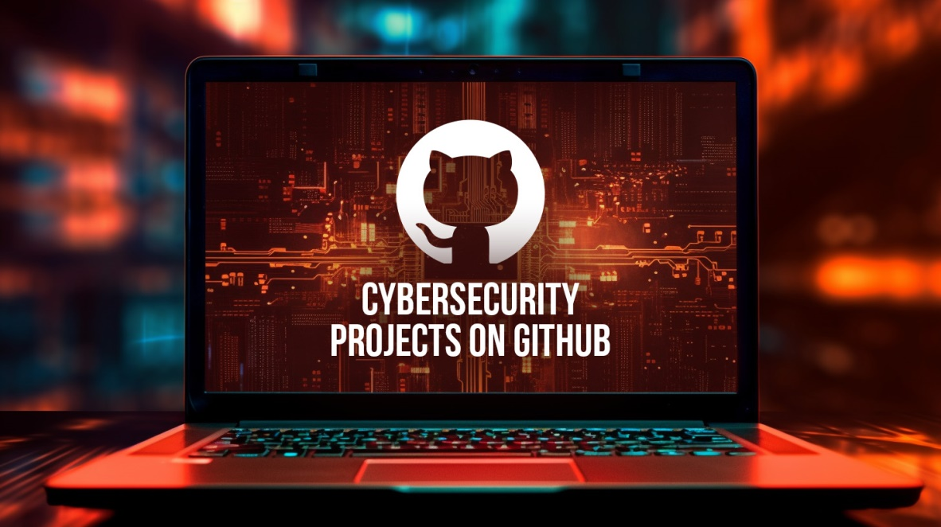As the field of cyber security is evolving, staying ahead of threats and maintaining a secure digital environment requires a combination of knowledge, tools, and collaboration. GitHub, a platform renowned for its role in software development, has become an indispensable resource for cybersecurity experts. Offering a vast array of tools, repositories, and collaborative features, GitHub empowers security professionals to develop, share, and refine solutions that protect against the ever-growing landscape of cyber threats.

Therefore, leveraging GitHub’s capabilities, cybersecurity experts can not only enhance their own skills but also contribute to the global effort in making the internet a safer place. GitHub is a powerful platform not only for software development but also for cybersecurity tasks. Here’s how you can use GitHub for various cybersecurity activities:

**How to Use Github in Cyber Security Task**

GitHub has emerged as a crucial tool in the cybersecurity domain, offering a versatile platform for managing, sharing, and automating security tasks. From hosting security tools and collaborating on research to automating vulnerability scans and conducting code reviews, GitHub provides a robust framework that enhances the efficiency and effectiveness of cybersecurity operations. Understanding how to leverage GitHub’s features can significantly improve your ability to develop secure software, respond to threats, and contribute to the broader cybersecurity community by:

**1. Hosting and Sharing Security Tools**

GitHub is an ideal platform for hosting and sharing security tools due to its collaborative features, ease of access, and widespread adoption in the tech community. Here’s how you can leverage GitHub for hosting and sharing your cybersecurity tools effectively:

#### 1. ****Creating Repositories for Security Tools****

When you create a public repository on GitHub, you can make your security tools available to the global community. Public repositories are accessible to everyone, making it easy for others to discover, use, and contribute to your project. If you’re developing a tool that you want to keep restricted, perhaps for internal use or until it’s ready for release, GitHub allows you to create private repositories. You can control who has access to these repositories, making it ideal for collaborative development within a secure environment.

#### 2. ****Version Control****

**Tracking Changes:** GitHub’s version control system allows you to track every change made to your security tools. This is crucial for maintaining the integrity of your tool, understanding its development history, and rolling back changes if necessary. It can create tagged releases for major versions of your tool, making it easier for users to download and use stable versions. Each release can include detailed notes about what has changed, new features, and bug fixes.

#### 3. ****Collaboration and Contributions****

**Also,** other users can fork your repository, creating their own copy where they can experiment, modify, or enhance your tool. If they make improvements, they can submit these changes back to your repository via a pull request. Pull requests are a powerful feature for collaboration. Contributors can propose changes, which you can review, discuss, and merge into your main codebase. This encourages community contributions and collective improvement of security tools. Moreso, GitHub allows users to report bugs, request features, or ask questions through the Issues and Discussions tabs. This interaction helps in refining the tool, addressing user concerns, and fostering a community around your project.

#### 4. ****Documentation****

The README file is often the first thing users see when they visit your repository. It should provide a clear description of your tool, how to install and use it, and any dependencies or prerequisites. A well-written README is essential for attracting and guiding users. For more detailed documentation, you can use GitHub’s built-in wiki or create a docs directory within your repository. Detailed guides, FAQs, and usage examples can help users and contributors understand your tool better.

#### 5. ****Licensing****

When sharing your security tools on GitHub, it’s important to include a license that dictates how others can use, modify, and distribute your tool. GitHub provides easy integration for various open-source licenses like MIT, GPL, Apache, etc. The license you choose will depend on how you want your tool to be used. For example, if you want others to freely use and modify your tool, the MIT License is a popular choice. If you want to ensure that modifications are also open-source, consider the GPL.

#### 6. ****Security Considerations****

When hosting security tools, it’s crucial to ensure that your code is secure. Regularly audit your code for vulnerabilities, and encourage contributors to do the same. GitHub offers security features like dependency scanning to help identify potential issues. Include a clear process for reporting vulnerabilities in your tool. You can set up a SECURITY.md file outlining how users can privately disclose security issues.

#### 7. ****Distribution and Integration****

GitHub allows you to upload compiled binaries or installation packages with your releases. This makes it easier for users to download and use your tool without needing to compile it themselves. Consider integrating your tool with package managers like Homebrew, PyPI, or NPM, depending on the language it’s written in. This can make installation even more seamless for users. Automate the building, testing, and deployment of your tool using GitHub Actions. This ensures that every change is validated and that users always have access to the latest stable version.

#### 8. ****Building a Community****

Lastly, it actively engage with users through GitHub Issues, Discussions, and by responding to pull requests. A responsive and active maintainer encourages more users to try out your tool and contribute to its development. Encourage users to share how they’ve used your tool in real-world scenarios. Highlight these use cases in your repository to demonstrate the practical applications of your tool.

**2. Collaboration on Security Research**

GitHub is a powerful platform for collaboration in security research, enabling researchers to work together from anywhere in the world. By hosting projects on GitHub, multiple contributors can share scripts, datasets, and findings in real time. Features like pull requests and code reviews allow researchers to contribute improvements, discuss potential vulnerabilities, and refine methodologies. Additionally, GitHub Issues and Discussions offer a centralized space for brainstorming, problem-solving, and documenting progress. This collaborative environment fosters innovation, allowing the cybersecurity community to collectively advance knowledge and develop more robust security solutions.

**3. Managing Security Documentation**

GitHub is ideal for managing security documentation due to its version control and collaboration features. You can store critical documents, such as security policies, incident response plans, and best practices, in repositories. Each document can be tracked for changes, ensuring that you always have access to the latest versions and can review the history of edits. GitHub’s wiki feature allows for the creation of comprehensive documentation hubs, while markdown files (like README.md) provide easily accessible and structured information directly in the repository. This setup ensures that security documentation is organized, up-to-date, and accessible to the relevant stakeholders.

**4. Automating Security Tasks**

GitHub provides powerful automation tools, like GitHub Actions, to streamline and enhance security tasks. You can set up automated workflows that run security tests, vulnerability scans, and code quality checks every time code is pushed or a pull request is opened. This ensures that potential security issues are identified and addressed early in the development process. Additionally, integrating tools like Dependabot can automatically update dependencies to patch known vulnerabilities, further securing your project with minimal manual intervention. Automation on GitHub helps maintain a consistent security posture across all stages of development.

**5. Security Audits and Code Reviews**

GitHub facilitates thorough security audits and code reviews, essential for maintaining high standards of security in your projects. Using pull requests, team members can review code changes line by line, providing feedback and identifying potential security vulnerabilities before the code is merged. GitHub’s issue tracker allows you to document and manage security findings, ensuring they are addressed in a timely manner. Additionally, third-party security tools can be integrated into the review process, automatically scanning the code for vulnerabilities. Regular audits and code reviews on GitHub help ensure that your software is robust and secure.

**6. Learning and Experimentation**

GitHub is an excellent platform for learning and experimentation in cybersecurity. It hosts a vast array of repositories containing tutorials, capture the flag (CTF) challenges, and sample projects that users can explore to develop their skills. Beginners can fork repositories to experiment with code, test different security scenarios, and learn best practices from industry experts. By studying open-source security tools and contributing to them, users gain hands-on experience and deepen their understanding of cybersecurity concepts in a practical, collaborative environment.

**7. Monitoring and Incident Response**

GitHub supports effective monitoring and incident response through its issue tracking and collaborative features. You can use GitHub Issues to track and manage security incidents, document vulnerabilities, and assign tasks to team members. The platform also allows for the creation of incident response playbooks and procedures within repositories, ensuring a standardized approach to handling security breaches. By monitoring activity on your repositories, such as unexpected changes or suspicious pull requests, GitHub helps you quickly detect and respond to potential security threats, minimizing the impact of incidents on your projects.

**8. Contributing to Open Source Security**

Contributing to open-source security on GitHub allows you to play a vital role in improving the security of widely used software. By identifying and reporting vulnerabilities, submitting patches, or enhancing existing security tools, you can help protect users and organizations worldwide. GitHub’s collaborative environment makes it easy to contribute, whether by forking repositories, submitting pull requests, or participating in security-focused projects. These contributions not only enhance the security of open-source software but also build your reputation in the cybersecurity community.

**9. Tracking Changes and Collaborations**

GitHub’s version control system enables precise tracking of changes across your projects, making it easy to monitor the evolution of your codebase. Every change is documented, allowing you to see who made updates, what was altered, and why. This transparency is crucial for maintaining a secure and reliable codebase. Additionally, GitHub facilitates collaboration by allowing multiple contributors to work on the same project simultaneously. Features like pull requests and code reviews ensure that changes are thoroughly vetted before being merged, fostering a collaborative yet controlled development environment.

**10. Community Engagement**

Community engagement is a cornerstone of success on GitHub, especially in the cybersecurity space. Engaging with the community involves actively participating in discussions, contributing to open-source projects, and collaborating with other developers and security professionals. By responding to issues, answering questions, and sharing your expertise, you help build a supportive and vibrant community around your project. GitHub Discussions provides a platform for more in-depth conversations, where users can exchange ideas, seek advice, and brainstorm solutions. Engaging with the community not only enhances your projects but also expands your network, fosters learning, and drives innovation across the broader cybersecurity landscape.

**Conclusion**

The importance of GitHub for cybersecurity experts cannot be overstated. It serves as a hub for innovation, learning, and collaboration, enabling professionals to tackle complex security challenges together. Whether through contributing to open-source security projects, automating security tasks, or engaging with the community, GitHub offers the tools and platform necessary for advancing the field of cybersecurity. By embracing GitHub, cybersecurity experts can significantly impact the security landscape, driving progress and ensuring that both organizations and individuals are better protected in an increasingly digital world.

GitHub is an essential tool in the cybersecurity toolkit, offering a wide range of functionalities for sharing, collaborating, automating, and managing security tasks. Whether you are conducting research, automating security checks, or contributing to the open-source community, GitHub can significantly enhance your cybersecurity efforts.